There were some initial pains when trying to understand the abstractness of the naming conventions, but after working with them for a bit it started making a lot more sense and the homework became pretty easy. The hardest/most annoying part was having to rebuild the behavior tree in the editor every time it wasn’t correct because I couldn’t load the old one in visually, and for the extra credit it all but required two monitors to make the tree even remotely legible. I realized after I had finished the behavior tree for the homework initially that I made it possible for the knight to navigate to the hallway regardless of spawn point which was a bit extra than what was required, which is when I decided to do the extra credit since I already had a behavior tree for each location. Both easy and challenging at the same time. Writing the code for the methods and new data structures etc. was the easy part, hooking them all up to each other and making the new behavior tree was the hard part, but in the end I made it work. Now regardless of where the knight spawns and regardless of where the potion spawns, as long as the potion doesn’t spawn behind the knight, the knight will grab the potion while navigating fully to the hallway.

Behavior Tree: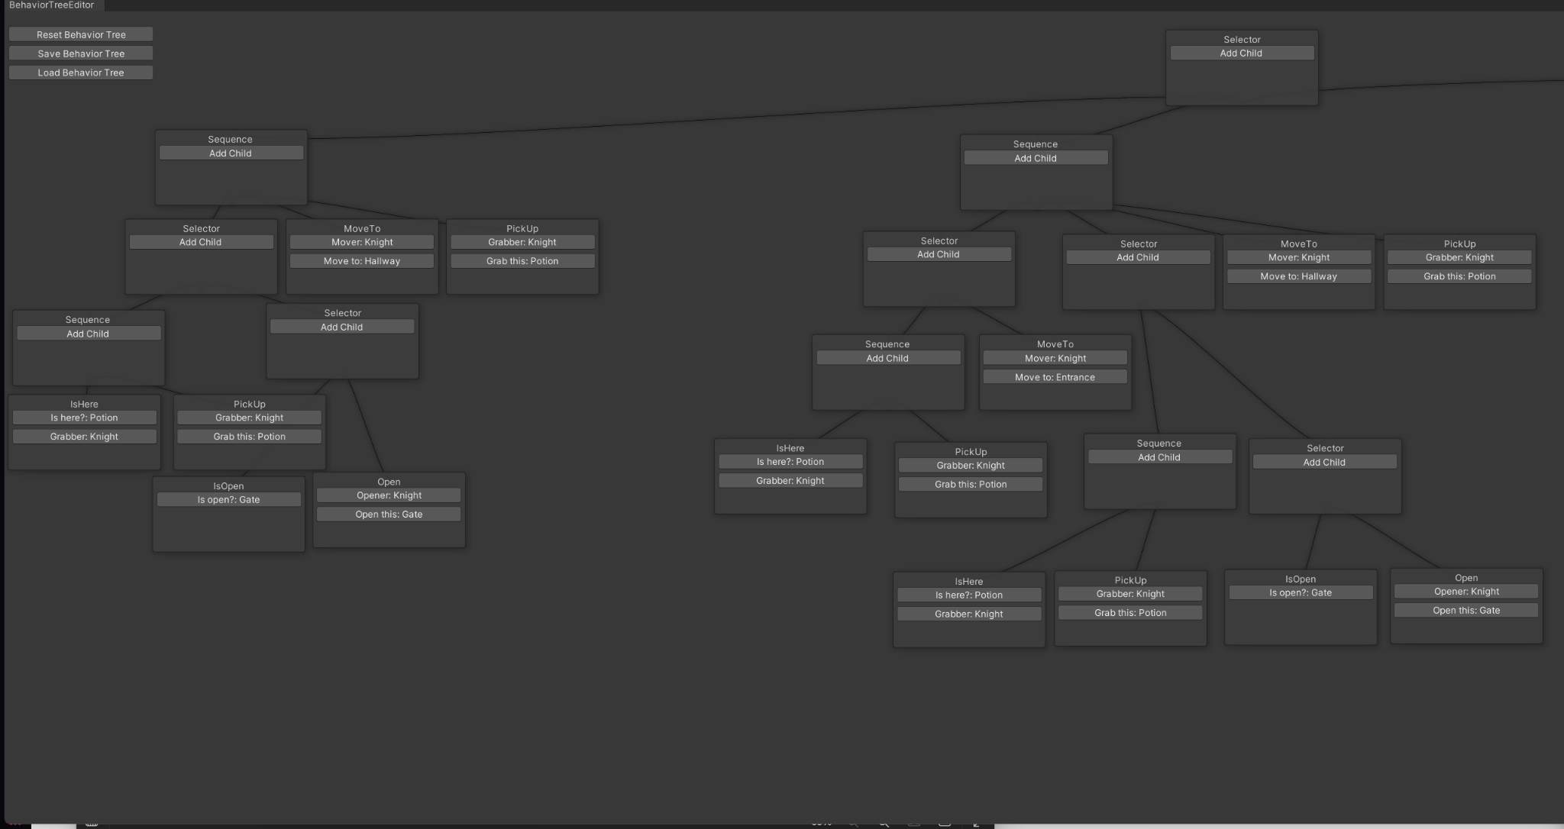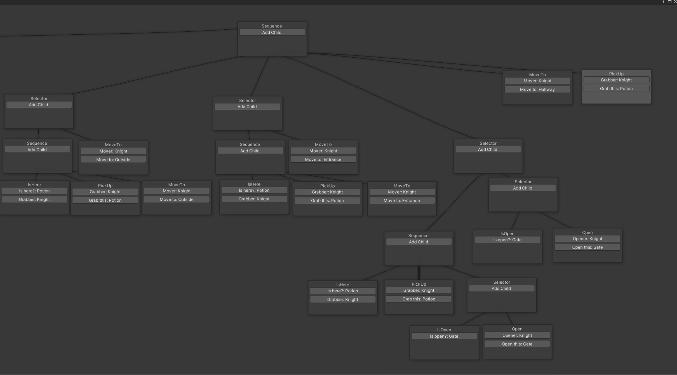

Debug logs for Knight spawning in Courtyard and potion spawning in Outside: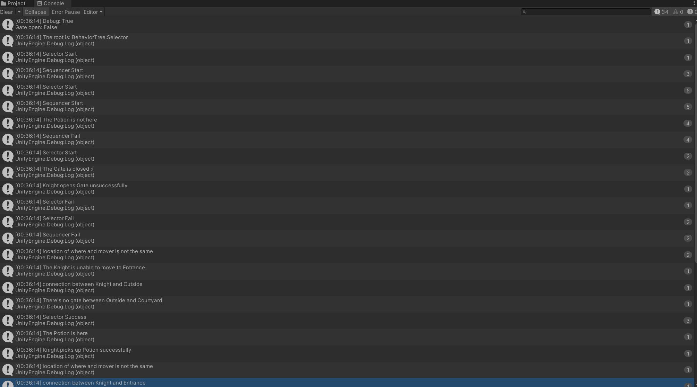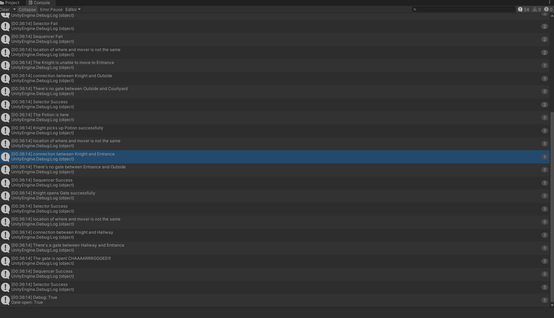

Scene view of above logs: 